**Hithesh Shanmugam**

**Assignment 2**

**CSC 481**

**Problem 1**

Image=imread('beanie.jpg'); %The image is saved in matlab

Image=rgb2gray(Image);

s=size(Image)

s = 1×2

1600 2560

x=round(s(1)/4)

x = 400

y=round(s(2)/4)

y = 640

new_image=zeros(x,y);

count=0;

p=1;

for i=1:4:(s(1)-4)

q=1;

for j=1:4:(s(2)-4)

new_image(p,q)=Image(i,j);

q=q+1;

count=count+1;

end

p=p+1;

end

**Part a**

new_image=uint8(new_image);

figure

imshow(new_image)



figure

imshow(Image)

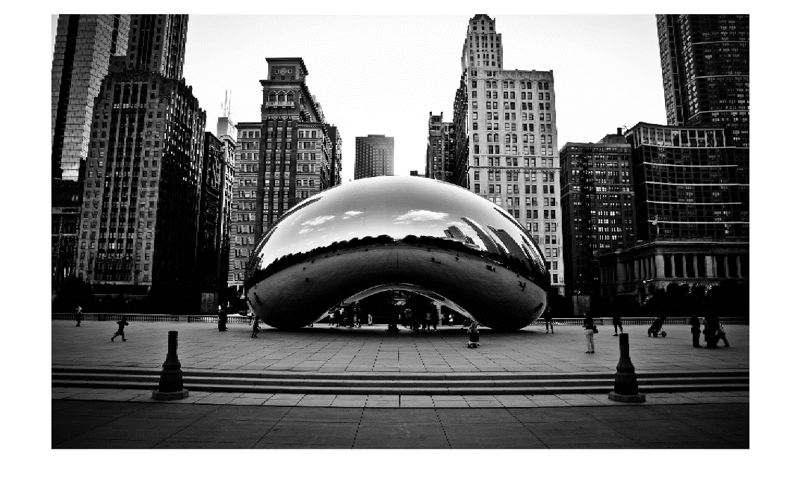

disp(count)

254961

disp(size(new_image))

400 640

**Part b**

Image=imread('shrink.jpg');

Image=rgb2gray(Image);

[x,y]=size(Image)

x = 254

y = 404

f_x=800;

f_y=1000;

scaled_x=4.0;

scaled_y=4.0;

Mat=zeros(f_x,f_y);

for count=0:f_x-1

for count_1=0:f_y-1

Mat(count+1,count_1+1)=Image(1+round(count./scaled_x),1+round(count_1./scaled_y));

end

end

subplot(1,2,1);imagesc(Image);colormap gray;

subplot(1,2,2);imagesc(Mat);colormap gray;

imwrite(Mat,gray(256),'shrink.jpg');

pause(5);

subplot(1,2,2)

ax = gca;

chart = ax.Children(1);

datatip(chart,680,323);

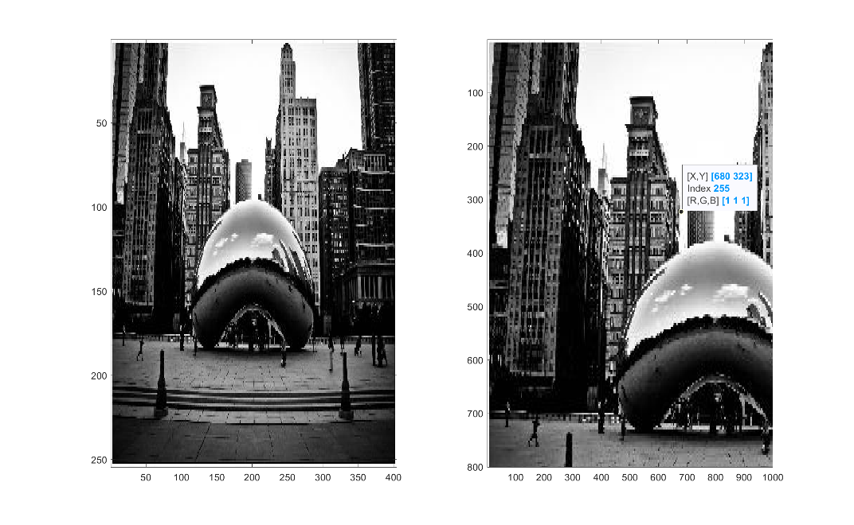

The reason for the difference in the image is because the original image has 1600 rows and 2560 columns and it has been shrunk by a factor of 4 and zoomed again by a factor of 4 that means the zoomed image has dimensions of

(Original image rows * zooming factor, Original Image cols * zooming factor)

As the zooming factor keeps increasing the image gets more blurred.

**Problem 2**

**Part a**

I = imread('apple.jfif');

figure

imshow(I)



**Part b**

negativeImage = 255-I;

figure

imshow(negativeImage)



**Part c**

I = rgb2gray(I);

J = imadjust(I) ;

figure

imshow(I)



